Map of the 7 Churches

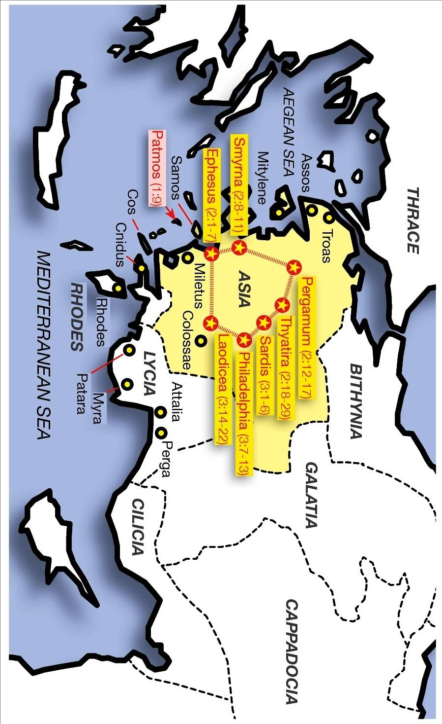
http://visualunit.files.wordpress.com/2010/06/rev_churches.jpg
12
Part 1 of 2 - Bible Conference Studies

The 7 Churches
Letters for the Church – Past, Present, Prophetical

April 20-22, 2012; Wausau, WI

Friday - April 20
7:00 - 8:00 pm Evening Prayer

Saturday - April 21
9:00 - 9:15 Prayer
9:15 - 10:30 Conference Overview
Study 1 - Revelation Introduced
10:30 Break
11:00 – 12:15 Study 2 - The Vision of Jesus Christ
12:15 Lunch
1:45 - 3:00 Study 3 - Church 1 of 7 - Ephesus
Visiting Workers Update
3:00 Break
3:30 - 5:00 Study 4 - Church 2 of 7 - Smyrna
Visiting Workers Update
Prayer
5:00 Supper
6:30 – 7:30 Hymn Sing & Open Ministry
8:00 Fellowship Activity

Sunday – April 22
9:15 - 10:30 Worship & Remembrance
10:30 Break
11:00 - 12:00 Sunday School
12:00 Lunch
1:45 - 2:45 Study 5 - Church 3 of 7 - Pergamum
2:45 Break
3:15 - 4:30 Open Ministry / Prayer

4:30 Supper

1
Descriptions of Jesus in Chapter 1

 | the faithful witness
 | the first-born of the dead
 | the ruler of the kings of the earth
 | who loves us and released us from our sins by His blood
 | made us to be a kingdom, priests to His God and Father
 | BEHOLD, HE IS COMING WITH THE CLOUDS
 | He was pierced
 | in the middle of the lampstands
 | one like a son of man
Judicial Role | clothed in a robe reaching to the feet,
 | girded across His breast with a golden girdle
 | His head and His hair were white like white wool, like snow
 | His eyes were like a flame of fire
 | His feet were like burnished bronze, when it has been caused to glow in a furnace
 | His voice was like the sound of many waters
 | In His right hand He held seven stars
 | out of His mouth came a sharp two-edged sword
 | His face was like the sun shining in its strength
 | I am the first and the last,
 | I was dead
 | I am alive forevermore, and
 | I have the keys of death and of Hades
 | the living One

Speak O Lord
Keith Getty & Stuart Townend

Conference Theme song - words removed on web release.

2
Prophetic History of Christendom

11
Study 5: Church 3 of 7 - Pergamum
Reading: Rev 2:12-17

Open Ministry 2: Sunday Afternoon

10

2 Year Study Outline
 | Study | Study Description | Rev
Year 1  2012 | 1 | Revelation Introduced | 1:1-8
 | 2 | The Vision of Jesus Christ | 1:9-20
 | 3 | Church 1: Ephesus | 2:1-7
 | 4 | Church 2: Smyrna | 2:8-11
 | 5 | Church 3: Pergamum | 2:12-17
Year 2  2013 | 6 | Church 4: Thyatira | 2:18-29
 | 7 | Church 5: Sardis | 3:1-6
 | 8 | Church 6: Philadelphia | 3:7-13
 | 9 | Church 7: Laodicea | 3:14-22
 | 10 | Summary | 1:1-3:22

Study Passage and Outline
Study 1:  Revelation Introduced  - Reading: Rev 1:1-8  - Why Revelation is written  - Who Revelation is to  - Who Revelation is from  Study 2:  The Vision of Jesus Christ  - Reading: Rev 1:9-20  - The vision’s background  - The vision  - The vision’s responses | Study 3:  Church 1 of 7 - Ephesus  - Reading: Rev 2:1-7  - Message to the 1st century church  - Message to the 21st century church  - Prophetic history considerations  Study 4:  Church 2 of 7 - Smyrna  - Reading: Rev 2:8-11  - Outline: same as Study 3  Study 5:  Church 3 of 7 - Pergamum  - Reading: Rev 2:12-17  - Outline: same as Study 3
3
Conference Introduction &
Study 1: Revelation Introduced
Reading: Rev 1:1-8

Study 2: The Vision of Jesus Christ
Reading: Rev 1:9-20

4
Open Ministry 1: Saturday Evening

Sunday School

9
Study 3: Church 1 of 7 - Ephesus
Reading: Rev 2:1-7

Study 4: Church 2 of 7 - Smyrna
Reading: Rev 2:8-11

8
The Divine Template

5

1: Ephesus  1 ¶ "To the angel of the church in Ephesus write: The One who holds the seven stars in His right hand, the One who walks among the seven golden lampstands, says this:  2 ‘I know your deeds and your toil and perseverance, and that you cannot endure evil men, and you put to the test those who call themselves apostles, and they are not, and you found them to be false;  3 and you have perseverance and have endured for My name’s sake, and have not grown weary.  4 ‘But I have this against you, that you have left your first love.  5 ‘Remember therefore from where you have fallen, and repent and do the deeds you did at first; or else I am coming to you, and will remove your lampstand out of its place—unless you repent.  6 ‘Yet this you do have, that you hate the deeds of the Nicolaitans, which I also hate.  7 ‘He who has an ear, let him hear what the Spirit says to the churches. To him who overcomes, I will grant to eat of the tree of life, which is in the Paradise of God.’ | 2: Smyrna  8 ¶ "And to the angel of the church in Smyrna write: The first and the last, who was dead, and has come to life, says this:  9 ‘I know your tribulation and your poverty (but you are rich), and the blasphemy by those who say they are Jews and are not, but are a synagogue of Satan.  10 ‘Do not fear what you are about to suffer. Behold, the devil is about to cast some of you into prison, that you may be tested, and you will have tribulation ten days. Be faithful until death, and I will give you the crown of life.  11 ‘He who has an ear, let him hear what the Spirit says to the churches. He who overcomes shall not be hurt by the second death.’ | 3: Pergamum  12 ¶ "And to the angel of the church in Pergamum write: The One who has the sharp two-edged sword says this:  13 ‘I know where you dwell, where Satan’s throne is; and you hold fast My name, and did not deny My faith, even in the days of Antipas, My witness, My faithful one, who was killed among you, where Satan dwells.  14 ‘But I have a few things against you, because you have there some who hold the teaching of Balaam, who kept teaching Balak to put a stumbling block before the sons of Israel, to eat things sacrificed to idols, and to commit acts of immorality.  15 ‘Thus you also have some who in the same way hold the teaching of the Nicolaitans.  16 ‘Repent therefore; or else I am coming to you quickly, and I will make war against them with the sword of My mouth.  17 ‘He who has an ear, let him hear what the Spirit says to the churches. To him who overcomes, to him I will give some of the hidden manna, and I will give him a white stone, and a new name written on the stone which no one knows but he who receives it.’ | 4: Thyatira  18 ¶ "And to the angel of the church in Thyatira write: The Son of God, who has eyes like a flame of fire, and His feet are like burnished bronze, says this:  19 ‘I know your deeds, and your love and faith and service and perseverance, and that your deeds of late are greater than at first.  20 ‘But I have this against you, that you tolerate the woman Jezebel, who calls herself a prophetess, and she teaches and leads My bond-servants astray, so that they commit acts of immorality and eat things sacrificed to idols.  21 ‘And I gave her time to repent; and she does not want to repent of her immorality.  22 ‘Behold, I will cast her upon a bed of sickness, and those who commit adultery with her into great tribulation, unless they repent of her deeds.  23 ‘And I will kill her children with pestilence; and all the churches will know that I am He who searches the minds and hearts; and I will give to each one of you according to your deeds.  24 ‘But I say to you, the rest who are in Thyatira, who do not hold this teaching, who have not known the deep things of Satan, as they call them—I place no other burden on you.  25 ‘Nevertheless what you have, hold fast until I come.  26 ‘And he who overcomes, and he who keeps My deeds until the end, TO HIM I WILL GIVE AUTHORITY OVER THE NATIONS;  27 AND HE SHALL RULE THEM WITH A ROD OF IRON, AS THE VESSELS OF THE POTTER ARE BROKEN TO PIECES, as I also have received authority from My Father;  28 and I will give him the morning star.  29 ‘He who has an ear, let him hear what the Spirit says to the churches.’ | 5: Sardis  1 ¶ "And to the angel of the church in Sardis write: He who has the seven Spirits of God, and the seven stars, says this: ‘I know your deeds, that you have a name that you are alive, but you are dead.  2 ‘Wake up, and strengthen the things that remain, which were about to die; for I have not found your deeds completed in the sight of My God.  3 ‘Remember therefore what you have received and heard; and keep it, and repent. If therefore you will not wake up, I will come like a thief, and you will not know at what hour I will come upon you.  4 ‘But you have a few people in Sardis who have not soiled their garments; and they will walk with Me in white; for they are worthy.  5 ‘He who overcomes shall thus be clothed in white garments; and I will not erase his name from the book of life, and I will confess his name before My Father, and before His angels.  6 ‘He who has an ear, let him hear what the Spirit says to the churches.’ | 6: Philadelphia  7 ¶ "And to the angel of the church in Philadelphia write: He who is holy, who is true, who has the key of David, who opens and no one will shut, and who shuts and no one opens, says this:  8 ‘I know your deeds. Behold, I have put before you an open door which no one can shut, because you have a little power, and have kept My word, and have not denied My name.  9 ‘Behold, I will cause those of the synagogue of Satan, who say that they are Jews, and are not, but lie—behold, I will make them to come and bow down at your feet, and to know that I have loved you.  10 ‘Because you have kept the word of My perseverance, I also will keep you from the hour of testing, that hour which is about to come upon the whole world, to test those who dwell upon the earth.  11 ‘I am coming quickly; hold fast what you have, in order that no one take your crown.  12 ‘He who overcomes, I will make him a pillar in the temple of My God, and he will not go out from it anymore; and I will write upon him the name of My God, and the name of the city of My God, the new Jerusalem, which comes down out of heaven from My God, and My new name.  13 ‘He who has an ear, let him hear what the Spirit says to the churches.’ | 7: Laodicea  14 ¶ "And to the angel of the church in Laodicea write: The Amen, the faithful and true Witness, the Beginning of the creation of God, says this:  15 ‘I know your deeds, that you are neither cold nor hot; I would that you were cold or hot.  16 ‘So because you are lukewarm, and neither hot nor cold, I will spit you out of My mouth.  17 ‘Because you say, "I am rich, and have become wealthy, and have need of nothing," and you do not know that you are wretched and miserable and poor and blind and naked,  18 I advise you to buy from Me gold refined by fire, that you may become rich, and white garments, that you may clothe yourself, and that the shame of your nakedness may not be revealed; and eye salve to anoint your eyes, that you may see.  19 ‘Those whom I love, I reprove and discipline; be zealous therefore, and repent.  20 ‘Behold, I stand at the door and knock; if anyone hears My voice and opens the door, I will come in to him, and will dine with him, and he with Me.  21 ‘He who overcomes, I will grant to him to sit down with Me on My throne, as I also overcame and sat down with My Father on His throne.  22 ‘He who has an ear, let him hear what the Spirit says to the churches.’"

